Azita Dadresan

Project #4 – Interactive Network Visualization using JavaScript, R, or Python

**Part I: Define and provide examples of the following list of features and concepts of graph theory. The**

**examples can be simple diagrams or screenshots.**

**1. Vertex**

"Vertex" is a synonym for a node of a graph, i.e., one of the points on which the graph is defined and which may be connected by graph edges. The terms "point," "junction," and 0-simplex are also used.

**2. Edge**

For an undirected graph, an unordered pair of nodes that specify a line joining these two nodes are said to form an edge. For a directed graph, the edge is an ordered pair of nodes.

**3. Undirected graph and 4. Directed graph**

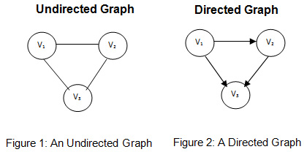

**5. Weighted graph**A weighted graph is a graph with edges labeled by numbers (called weights). In general, we only consider nonnegative edge weights.

**6. Complete graph**A graph consisting of vertices and line segments such that every line segment joins two vertices, and every pair of vertices is connected by a line segment.

**7. In-degree and 8. Out-degree**

In-degree is the number of connections that point inward at a vertex. Out-degree is the number of connections that originate at a vertex and point outward to other vertices.

**9. Adjacency Matrix**

In graph theory and computer science, an adjacency matrix is a square matrix used to represent a finite graph. The elements of the matrix indicate whether pairs of vertices are adjacent or not in the graph. In the special case of a finite simple graph, the adjacency matrix is a (0,1)-matrix with zeros on its diagonal.

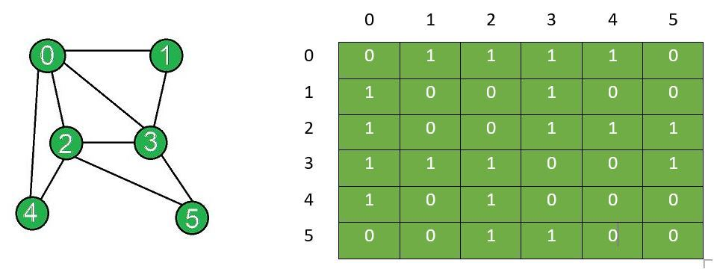

**10. Edge-set representation**

A graph G with a set of V vertices together with a set of E edges is represented as G= (V, E). Both vertices and edges can have additional attributes that are used to describe the entities and relationships.

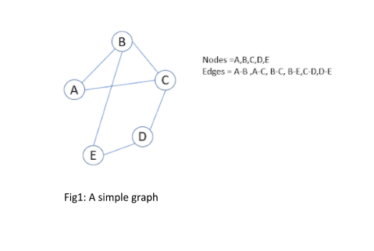

**Part II:**

**Shape 1:** The node color is changed to green, and it shows the labels. All edges show the weights and the directions for the edges. The benefit is showing the nodes and the weights of the data.

**Shape 2:** The node color is changed to purple, and it shows the labels.

The position layout is circular to show the nodes better.

**Shape 3:** The node color is changed to blue, and it shows the labels with bigger font size, the edge colors are black, but dashed. The layout position is spiral. Maybe it is good for focusing more in the middle or the ratio.

**Shape 4:** In addition to node size and color, the edge colors are changed to green. The benefit is showing everything clearly and it is more readable.

**Shape 5:** All edges and node colors and shapes are changed. The benefit is showing everything clearly.

Reference:

<https://www.youtube.com/watch?v=LFKZLXVO-Dg&ab_channel=Reducible>